

**Conservation Model**

**LIFE**

**Quickbase # 1826**

**Product Market Requirements (PMR) Document**

Version 1.1

**CONFIDENTIAL & PROPRIETARY**

The recipient of this material (hereinafter “the Material”) acknowledges that it contains confidential and proprietary data the disclosure to, or use of which by, third parties will be damaging to LexisNexis Inc and its affiliated companies (hereinafter “LexisNexis”). Therefore, recipient agrees to hold the Material in strictest confidence, not to make use of it other than for the purpose for which it is being provided, to release it only to employees requiring such information, and not to release or disclose it to any other party. Upon request, recipient will return the Material together with all copies and modifications, if any.

All names in the text, or on the sample reports and screens shown in this document, are of fictitious persons and entities. Any similarity to the name of any real person, address, school, business or other entity is purely coincidental.

The trademarks, logos, and service marks (collective the “Marks” or “Mark”) appearing in this document are registered and unregistered Marks of LexisNexis and others. The information contained herein does not constitute a grant of any license or right to use any Mark displayed on this document. LexisNexis aggressively enforces its intellectual property rights.

**TABLE OF CONTENTS**

1. Documentation Revision History 4

2. Documentation Guidelines 4

3. Key Contacts 5

4. Vertical Market 5

5. Target Implementation Date/Quarter 5

6. Initiative Purpose 5

7. Product/Service Requirements 6

8. Contributory Requirements 8

9. Rule Plan Requirements 8

10. Modeling Requirements – See Appendix A 8

11. Third Party Data and Vendor Requirements 8

12. Volume, SLA, Performance, Availability, Data Retention 8

13. MBSi Requirements – N/A 8

14. Testing – N/A 8

15. Legal 8

16. Security Assessment 8

17. Sales Tax 9

18. Appendix A – Model Information 14

19. Appendix B – Data/Field Layouts 14

Appendix A 15

1. Documentation Revision History

|  |  |  |  |
| --- | --- | --- | --- |
| **Version** | **Date** | **Author** | **Remarks/Comments** |
| 1.0 | 8-01-2013 | Susan Goss | Initial Draft |
| 1.1 | 8-07-2013 | Susan Goss | Clarifications after Technology Review |
| Baseline |  |  | Baseline Document Completed |
| **Change Request** |  |  |  |
| CR1 |  |  |  |
| CR2 |  |  |  |
| CR3 |  |  |  |

1. Documentation Guidelines

|  |  |
| --- | --- |
| **Document**  **Author** | This originates from the market vertical team and expanded on by the Product Manager or New Product Execution team member. |
| **Document Purpose** | The document defines purpose, requested product solution functionality, exceptions, performance requirements, legal and regulatory compliances, and operational requirements. |
| **Document Audience** | The Technology and *Rules Business Analyst teams will use this document to determine the system and technical specifications. |
| **Expected Outcome** | Ensure a common understanding among the project delivery team, of the market problem being solved and the proposed solution. |
| **Document Reviewer** | Market Vertical, Technical Design teams, and the appropriate operational stakeholders. Refer to the [Product Release Checklist](http://teamsites.choicepoint.net/insurance/pncmkt/pmm/Templates/Prod%20Dev%20-%20Product%20Release%20Checklist/Product%20Release%20Checklist%20-%20RACI.xls) for a complete list. |
| **Document Approver** | Document must be approved by Technical and Market Vertical teams to ensure all Vertical requirements are met and clearly enunciated. |
| **Document Destination** | New Product Execution Team SharePoint document repository. |
| **Additional**  **Helpful Tips** | Additional requirements and approvals may be required if other groups such as Rules Business Analysts and Modeling Analytics are affected.  This document may contain more headings/categories than applicable for your product solution. Simply indicate NA-Not Applicable, to illustrate that all areas were proactively considered. |

1. Key Contacts

|  |  |  |
| --- | --- | --- |
| **Name** | **Title** | **Responsibility** |
| Donnamarie Blake | Business Vertical | Responsible for defining product/solution concept based on needs and requirements from the market. |
| Susan Goss | New Product Execution | Responsible for defining the business requirements for the initiative. |
| TBD | Product Management | Responsible for managing the initiative once in production. |
| Stephanie Amos | Engineering Project Management | Responsible for the project schedule and coordination of development, testing and production implementation. |
| John Siders  Becky Champion | Batch R3 Development  Technical Lead | Responsible for the design, development and implementation of the initiative into the LN infrastructure. |
| N/A | Rules Business Analyst | Responsible for the Rules functional specifications for integration into the implementation. |
| Aaron Hale  Becky Champion | Modeling  Modeling Development | Responsible for defining and creating the model which will be used for initiative. |
| N/A | Customer Test | Responsible for developing appropriate customer test cases. |
| David Benson | QC | Responsible for testing system and application functionality as outlined in the PMR. |
| N/A | MBSi | Responsible for development of account setup, product configuration, billing, support tool, management reports and consumer disclosure. |

1. Vertical Market – Life
2. Target Implementation Date/Quarter– Q4 2013
3. Initiative Purpose
   1. **Executive Summary** – Life Insurance carriers have not had a solution that helps them predict the persistency of their applicants. The Life Conservation Model will adopt the Attract Life Persistency Credit Model format, using  public record data  attributes to provide a predictive score on the likelihood of an applicant allowing his/her life insurance policy to lapse during the first 12 to 24 months.

**Market Opportunity** – Life Carriers have a need for a model to predict which of their in-force policyholders are likely to lapse or surrender, particularly within 12 or 24 months of inception. Based on the output from a model, insurers can focus their conservation efforts on most policies likely to lapse that they desire to keep. After the 24 month period that a policy is in-force, insurers do not have a permissible purpose to pull credit or take an adverse action on these insureds. So the existing LexisNexis FCRA, credit-based Attract Model is undesirable. Given the desire to grow their book of business, Life Carriers are not inclined to reject applicants for underwriting reasons, even if they knew that certain applicants would be more likely to lapse. Rather, they would use this knowledge to determine eligibility for things like face amount, policy type (Term or Whole Life), payment terms (e.g., require EFT), or even producer compensation.

* 1. **Financial Objective** – Year 1 $25,000 in 2014

Year 2 $91,000 in 2015

Year 3 $123,000 in 2016

* 1. **Assumptions –** none
  2. **Constraints** – none

1. Product/Service Requirements
   1. **Overview** – The Conservation model outputs a score from 200–999. The score rank orders the likelihood of an insured or applicant having a policy lapse or surrendering the policy. Low scores correspond to higher attrition rates while high scores indicate a lower propensity of insureds to lapse or surrender. Reason codes have not been developed as the score will not be used to make adverse actions. Since Life Carriers are more interested in knowing which of their in-force book is likely to lapse or surrender, it is critical to have batch scoring capabilities available. The public record attributes need to be appended to their in-force block of policies so that the scores can be calculated for each policy. Then based on the threshold the carrier has set from a retro-validation analysis, policies below the threshold will be flagged for their conservation program.

* + 1. For each carrier, it will be necessary to conduct a retro validation analysis to set a score threshold to determine which policies should be targeted for conservation. This will also require a batch process. Insurers will need to provide historical policy data with the effective and cancellation dates, name, address, and date of birth. The public records attributes will be appended to this data and scores will be calculated.

8.0 **Data** – The current model uses 19 modeling attributes derived from the Boca 4.0 Shell.  Attributes such as the subject’s wealth, address stability, presence of a professional license or a bankruptcy, dwelling type, number of all unreleased liens, age, and others are predictive of lapse rate.

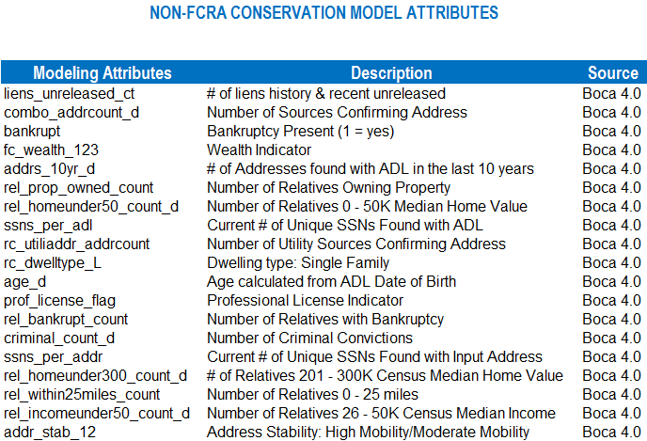

* 1. Compliance/Restrictions – The Life Conservation Model is non-FCRA.

The GLB code to be logged is “6” – For required institutional risk control.

* 1. Contract Restrictions:

Customer level contracts to include GLB language (this provides a check and balance at account set up of product). This Model may not be used for Marketing purposes.

* 1. Interface – Offline/batch special projects
  2. Delivery System – Offline .csv file
  3. Process Flow

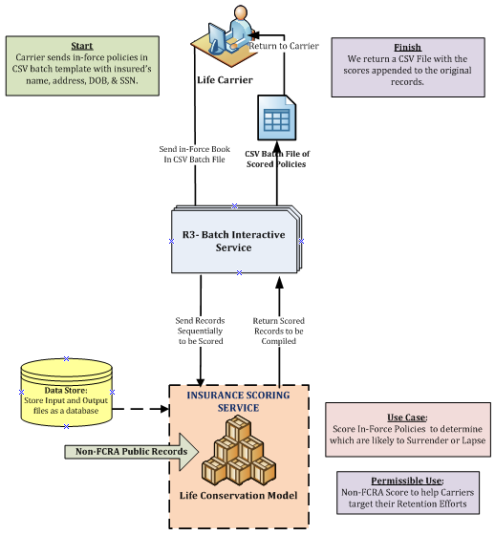

* 1. **Format** – .csv file
  2. **Inquiry –** Name, address, date of birth, and the effective date listed on policy are required inputs. Social Security Number is optional.
  3. **Result** – The Insurance Scoring Service output will return the input data with a three digit numerical score from 200 to 999. Based on the threshold the Carrier has set from a retro-validation analysis, policies below the threshold will be flagged with an indicator.
  4. **Processing** – The Carrier file can be sent in System to System batch or manually (e-mail). The Carrier will FTP the .csv file via Data Communications. The file will be processed through the Insurance Scoring Service (ISS). The result .csv batch file will be placed on a landing zone for the Carrier to pick up or manually sent to the Carrier.
  5. **Standard Common Status Codes** – **N/A**

1. Contributory Requirements **– N/A**
2. Rule Plan Requirements **– N/A**
3. **Modeling Requirements** – See Appendix A

1. Third Party Data and Vendor Requirements **– N/A**
2. Volume, SLA, Performance, Availability, Data Retention
   1. Expected volumes – 5000 transactions per month (1 to 2 files), ramp up over time. Future Batch files could have up to 10 million records.
   2. Expected performance – over night batch file processing.
   3. Data retention requirements – inquiry and results will be stored by Analytics

1. MBSi Requirements – N/A
   1. **Management Reports – N/A**
   2. **Consumer Disclosure** – N/A – Non-FCRA offering.
   3. **Billing** – Manual Billing applies.
2. Testing – QC – Batch and Scoring end to end testing.
3. Legal
   1. Legal approval has been obtained – Yes
   2. The Conservation Model cannot be sold for Marketing purposes.
4. Security Assessment
   1. Security/PSCO approval has been obtained – Yes Ticket #2599426
5. Sales Tax

|  |  |  |
| --- | --- | --- |
|  | **Questions for Assessing Taxability of product/service** | **Response** |
| 1 | What company / legal entity is selling the product/service? |  |
| 2 | What is it exactly that we are selling?  Identify if there is a web site that has additional background information. |  |
| 3 | Are we selling this product/service to an end user or is it being resold? |  |
| 4 | Who are the customers? |  |
| 5 | Is the product/service in an electronic or print format? |  |
| 6 | What is the medium of transmission ( i.e. is the product/service shipped on a disk, e-mailed, load and leave, electronically transmitted, or accessed via software or a through a website)? |  |
| 7 | Is a software license being granted (i.e. a license to use computer software or the right to use and access computer software via software as a service model?) |  |
| 8 | Who initiates the transmission of the product/service? |  |
| 9 | Do we send the product/service to the customer or does the customer retrieve it? |  |
| 10 | Is there any tangible personal property associated with the sale of this product/service? |  |
| 11 | How do we bill for this product/service?  Is this a bundled charge or do we charge separately for different features of the product/service? |  |
| 12 | If the product/service includes data or information, is it personal and individual in nature such that no other customer can use the information? |  |
| 13 | Does this product/service generate any reports or files which can be used by other customers? |  |
| 14 | If there is a transmission of software or access to software via internet, is it canned or customized? |  |
| 15 | Can we obtain sample invoices or contracts? |  |
| 16 | Is this product shipped to or used in specific jurisdictions? |  |
| 17 | Is this product / service used in multiple jurisdictions and if so, can we obtain a breakdown of the use in each jurisdiction? |  |
| 18 | If the product is shipped, what are the terms of shipment?  Is a common carrier used?  Are goods dropped shipped? |  |
| 19 | Is there a maintenance component to the sale?  If so, is it mandatory or optional? |  |
| 20 | Are the different maintenance components separately stated on the customer invoices? |  |
| 21 | What is the delivery method, load and leave, electronic, or TPP?  What does the customer receive via the maintenance component? (i.e. phone support, email support, computer software upgrades, etc.?) |  |
| 22 | If the customer receives computer software upgrades, how are the upgrades provided (i.e. via diskette, emailed, downloaded, access through a website?) |  |
| 23 | Who is the product champion that would be the best contact for additional information? |  |
| 24 | What is the timeframe for rollout? |  |
| 25 | Is this an entirely new product/service or is this a subsequent phase of an existing product/service?  Will there be additional phases that need to be considered? |  |

**Appendices** – as applicable

1. Appendix A – Model Information
2. Appendix B – Data/Field Layouts

Appendix A

**LIFE NON-FCRA CONSERVATION MODEL**

**Product Description**

**Vertical**

Life

**Business Objective**

Life Carriers have a need for a model to predict which of their in-force policyholders are likely to lapse or surrender, particularly within 12 or 24 months of inception. Based on the output from a model, insurers can focus their conservation efforts on those policies likely to lapse that they desire to keep. As these policies are in-force, insurers do not have a permissible purpose to pull credit or take an adverse action on these insureds. So the existing LexisNexis FCRA, credit-based Attract Model is undesirable.

Given the desire to grow their book of business, Life Carriers are not inclined to reject applicants for underwriting reasons. Even if they knew that certain applicants would be more likely to lapse, they do not necessarily want to reject them. Rather, they would use this knowledge to determine eligibility for things like face amount, policy type (Term or Whole Life), payment terms (e.g., require EFT), or even producer compensation. Hence, a non-FCRA model would be desirable at new business as the score would not be used for adverse actions or pricing.

**Solution Description**

The LexisNexis Conservation model is built from Public Records Attributes for non-FCRA purposes. Attributes such as the subject’s wealth, address stability, presence of a professional license or a bankruptcy, dwelling type, number of all unreleased liens, age, and others were predictive of lapse rate. The model uses logistic regression since the response variable (Y) is either a “yes” or “no” (the insured either lapses/surrenders or does not).

Based on a test performed with client data, the Non-FCRA Model tracked favorably with the FCRA Attract Model, although it was not quite as predictive. This is a result of not using consumer credit attributes. The trade-off, however is that a public record model is less costly than a credit-based model and can be used to score in-force policies. In order to further validate the effectiveness of the model, data from several other carriers will be run through the model on an individual and combined basis.

**Input**

In order to score a company’s in-force book of business, the name, address, date of birth, and the effective date listed on policy are essential inputs. Social Security Number is optional.

**Output and Delivery**

The model outputs a score from 200–999. The score rank orders the likelihood of an insured or applicant having a payment lapse or surrendering the policy. Low scores correspond to higher attrition rates while high scores indicate a lower propensity of insureds to lapse or surrender. Reason codes have not been developed as the score will not be used to make adverse actions. However, they could be derived if the information is deemed useful in assisting carriers fine-tune their conservation efforts.

Since Life Carriers are more interested in knowing which of their in-force book is likely to lapse or surrender, it is critical to have batch scoring capabilities available. The public record attributes need to be appended to their in-force book so that the scores can be calculated for each policy. Then based on the threshold the carrier has set from a retro-validation analysis, policies below the threshold will be flagged for their conservation program.

For each carrier, it will be necessary to conduct a retro validation analysis to set a score threshold to determine which policies should be targeted for conservation. This will also require a batch process. Insurers will need to provide historical policy data with the effective and cancellation dates, name, address, and date of birth. The public records attributes will be appended to this data and scores will be calculated. From these scores, Gains Tables can be generated to help understand the correlation between the scores and the percent of the actual lapse/surrender rates in the insurers’ books. From the Gains Tables, a threshold can be set which maximizes the likelihood of a payment lapse or surrender in the next 12 or 24 months.

**Boca Shell 4.0 Attributes**

The current model uses 19 modeling attributes derived from the Boca 4.0 Shell. These are displayed below with a brief description.

